

**Comprehensive Relative Strength Analysis & Visualizations**

Based on your RS data for stocks, sectors, and industries, I've created multiple visualizations and analyses to help you understand market dynamics and identify opportunities.

**Key Visualizations Created**

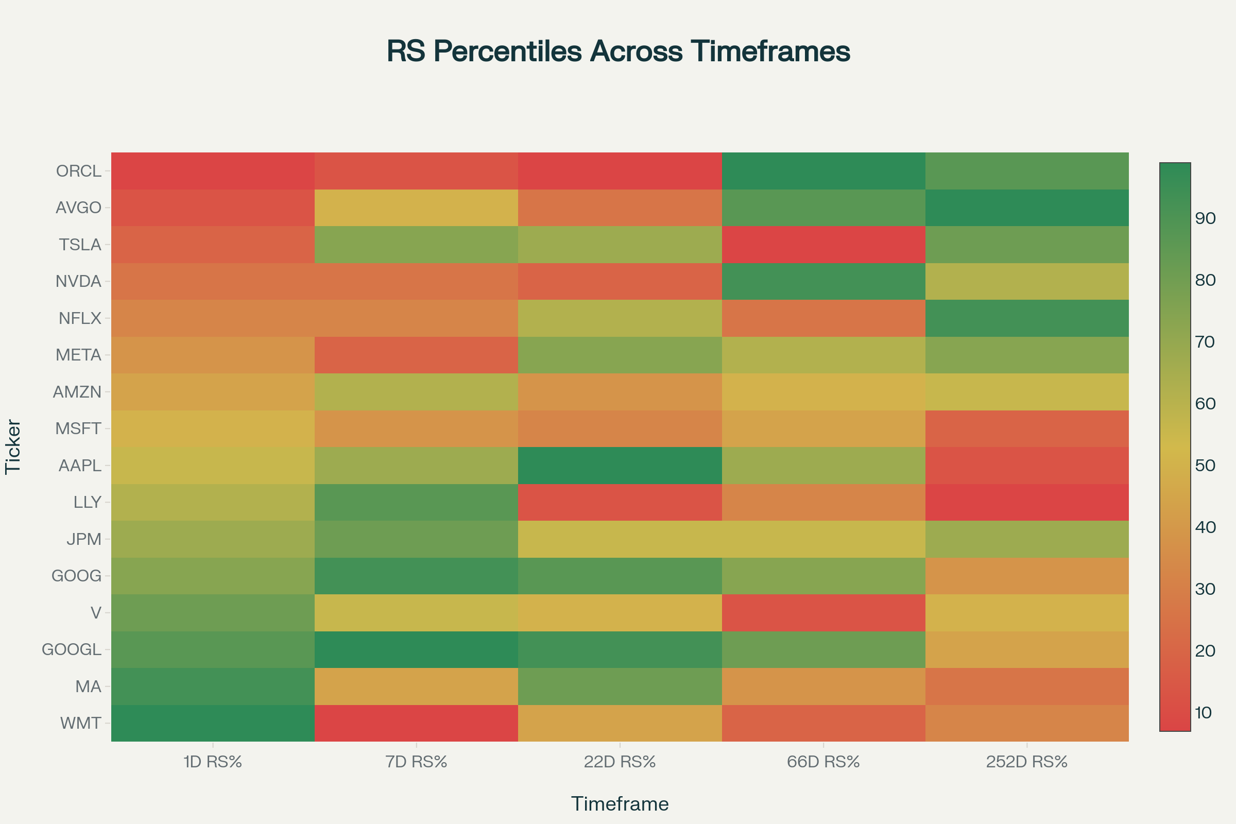

Stock RS Percentile Heatmap Across Multiple Timeframes

The **RS Percentile Heatmap** shows relative strength patterns across multiple timeframes for all 16 major stocks. **GOOGL and GOOG dominate** with consistently high RS percentiles, while stocks like **ORCL and AVGO** show interesting long-term strength despite short-term weakness.

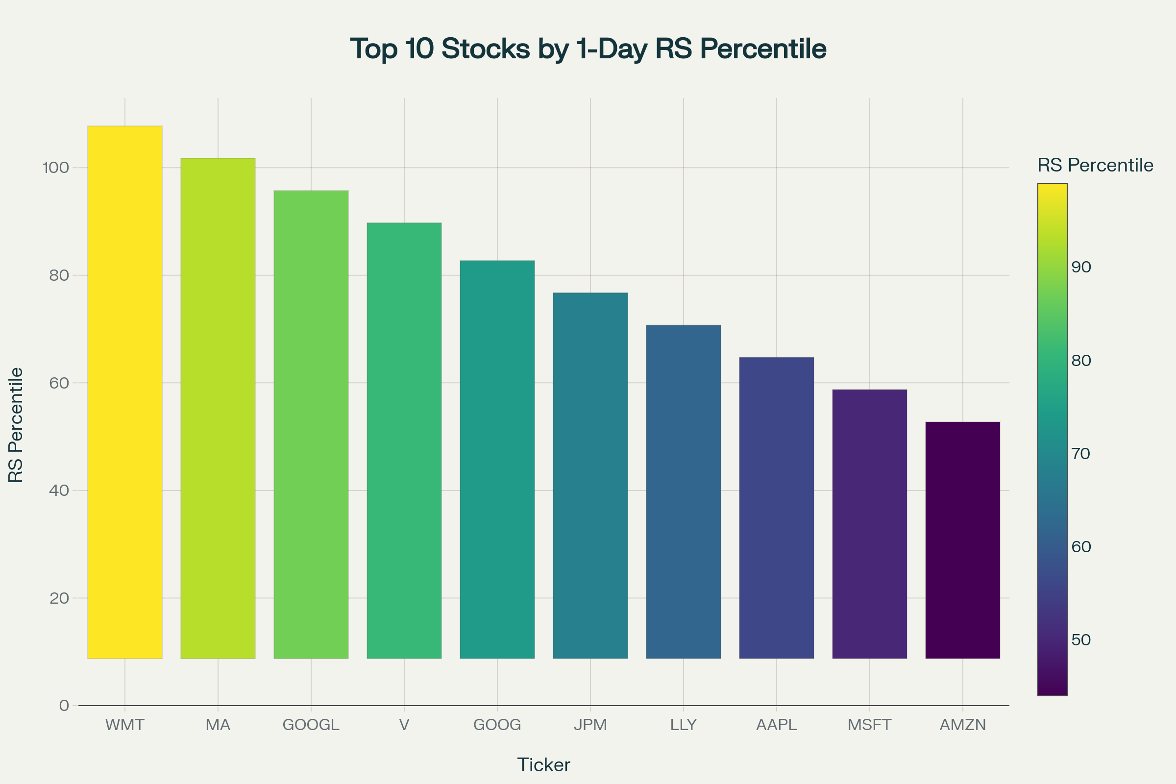

Top 10 Stocks by 1-Day Relative Strength Percentile

This **Top 10 Daily RS Leaders chart** highlights current market leadership, with **WMT leading at the 99th percentile** followed by **MA, GOOGL, and V** in the top tier.

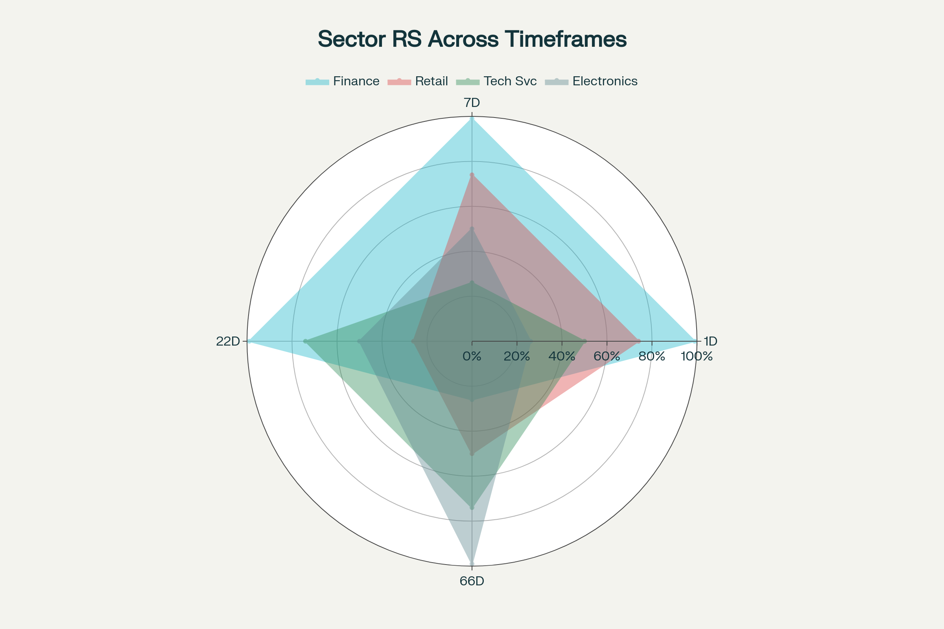

Sector RS Performance Radar Chart Across Timeframes

The **Sector Radar Chart** reveals clear sector rotation patterns - **Finance sector dominates short-term timeframes** (1D, 7D, 22D) while **Electronic Technology shows strength in longer periods** (66D).

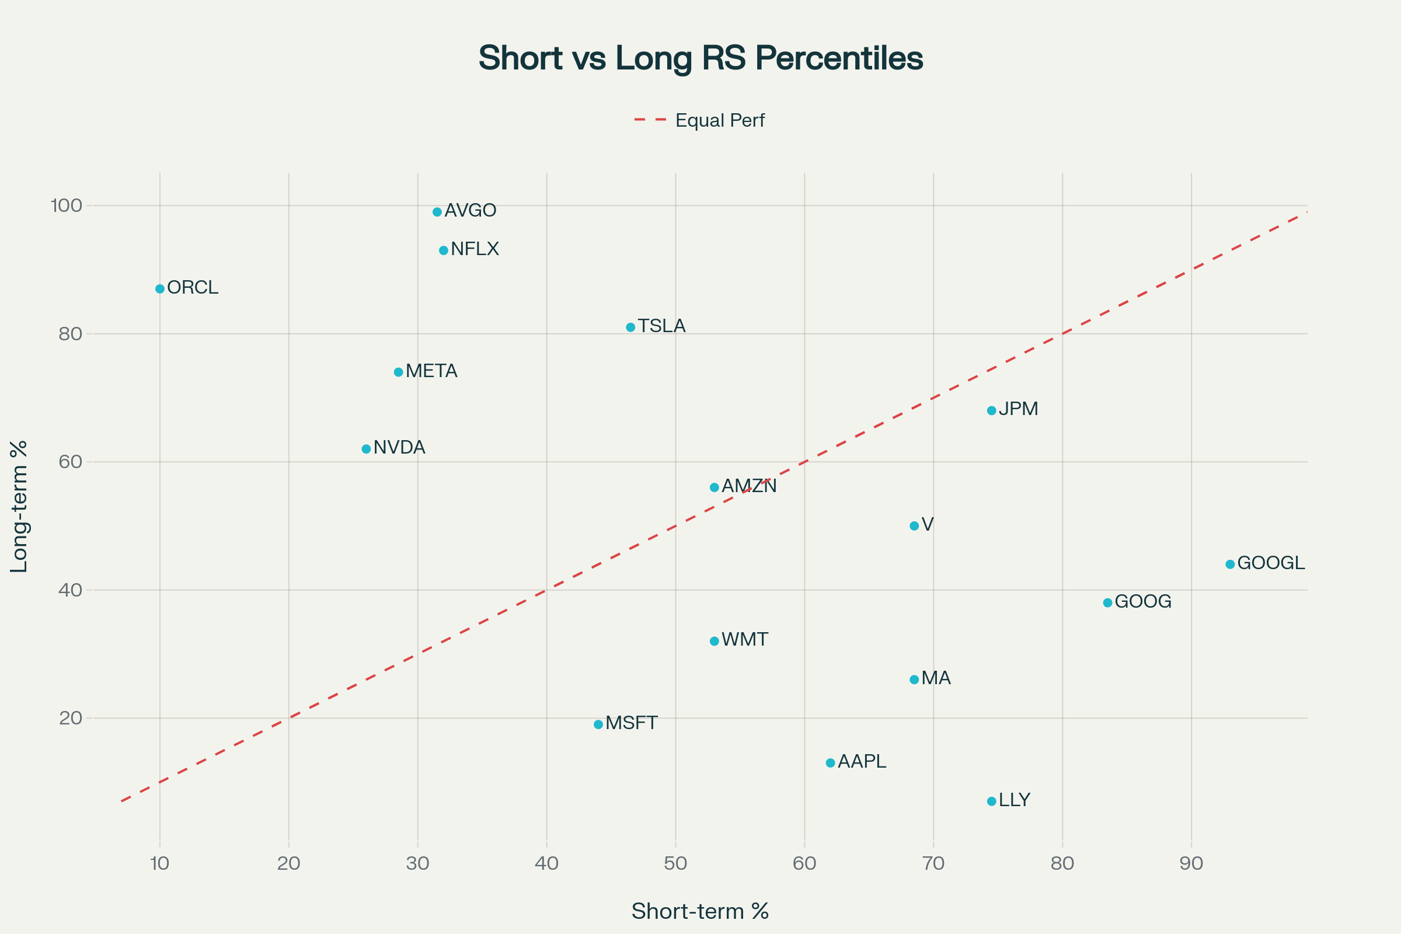

Short-term vs Long-term RS Performance Scatter Plot

This **scatter plot** effectively separates momentum plays from value opportunities. Stocks **below the diagonal line** (like LLY, AAPL, GOOGL) show stronger short-term momentum, while those **above the line** (like ORCL, AVGO, NFLX) indicate potential turnaround candidates with strong long-term RS.

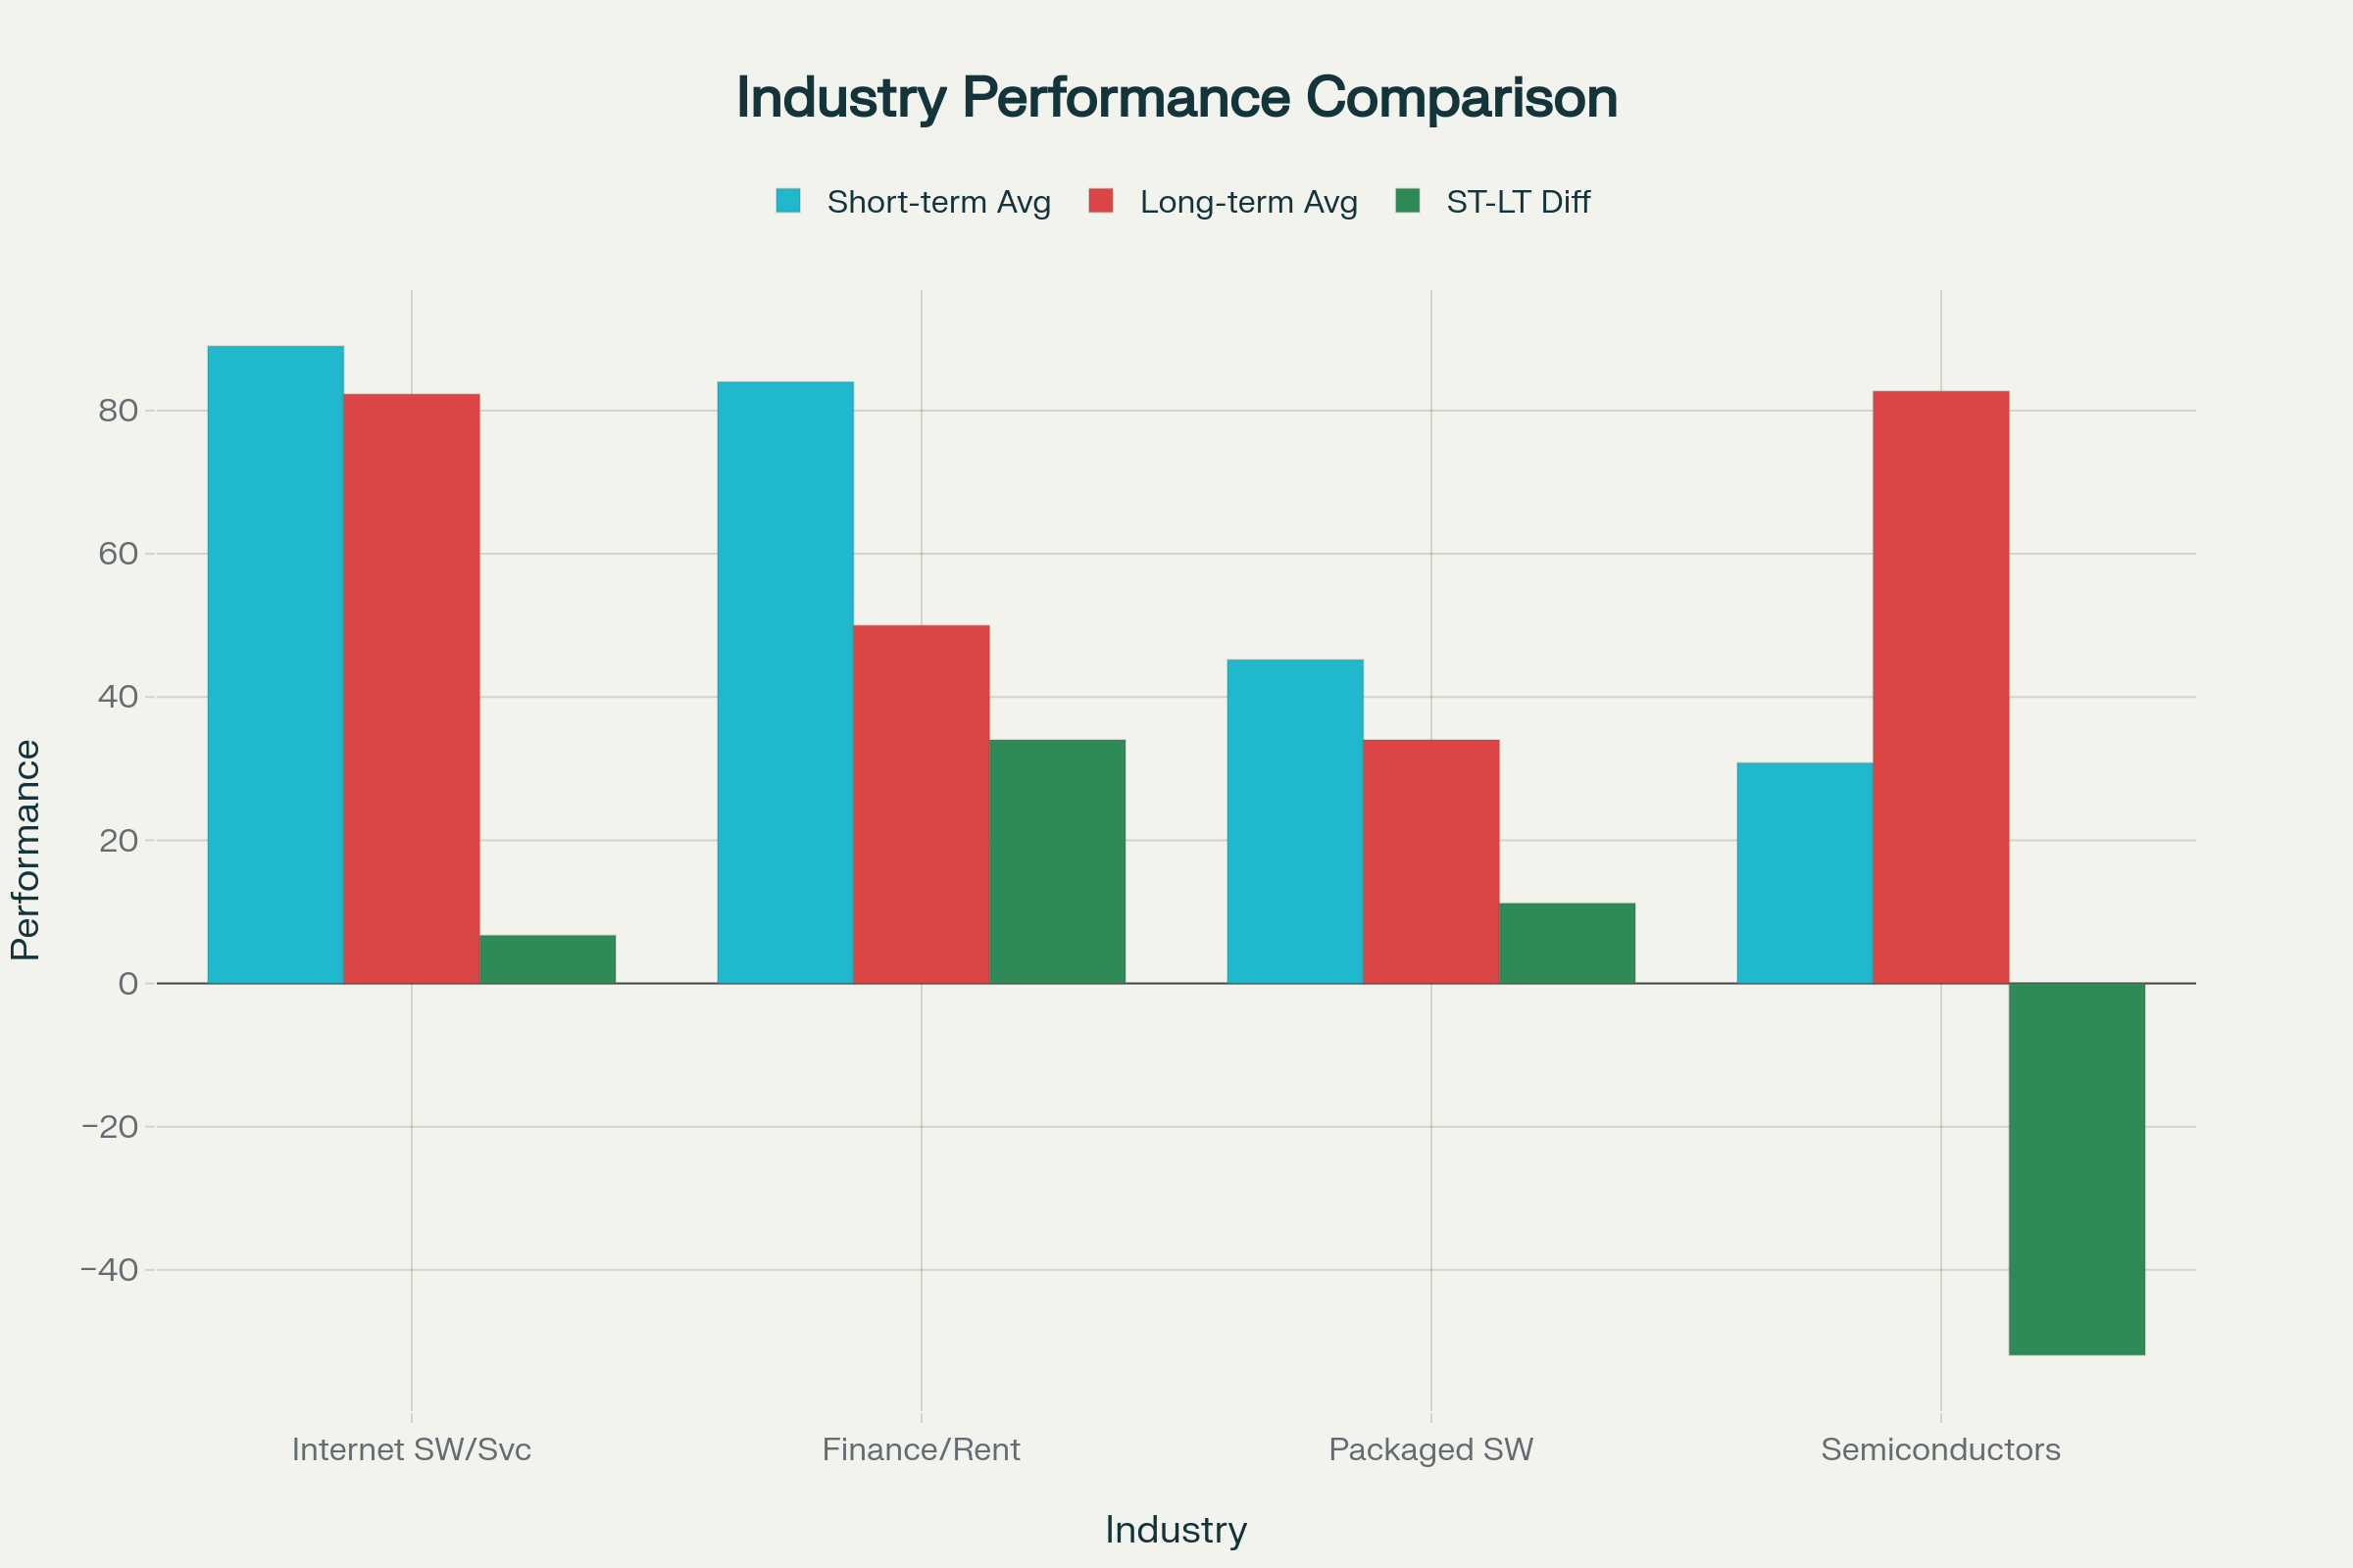

Industry Performance Comparison: Short-term vs Long-term RS

The **Industry Performance Comparison** shows **Internet Software/Services** leading in short-term performance while **Semiconductors** display strong long-term momentum despite recent weakness.

**Key Market Insights Discovered**

**Current Market Leaders (1-Day RS)**

* **Stocks**: WMT (99th percentile), MA (93rd), GOOGL (87th)
* **Sectors**: Finance (99th percentile) - indicating possible rotation INTO finance
* **Industries**: Finance/Rental/Leasing (99th percentile)

**Momentum Pattern Analysis**

* **Most Consistent Performers**: GOOGL, GOOG, JPM show stable high RS with low volatility
* **Strongest Short-term Momentum**: LLY (+67.5% vs long-term average)
* **Strongest Long-term Value**: ORCL (-77.0% short-term vs long-term gap)

**Actionable Trading Insights**

1. **Watch List** (consistent high RS): GOOGL, GOOG, JPM, AAPL, V
2. **Momentum Plays** (strong short-term): LLY, AAPL, GOOGL
3. **Value/Turnaround** (strong long-term, weak short-term): ORCL, AVGO, NFLX
4. **Sector Focus**: Finance shows short-term leadership; Semiconductors offer long-term value

**Data Analysis Summary**

The analysis reveals **clear momentum divergences** and **sector rotation patterns**. Finance sector dominance in short-term timeframes suggests institutional rotation, while the semiconductor industry's long-term strength despite short-term weakness presents potential value opportunities. The comprehensive dataset enables identification of both momentum continuation plays and mean-reversion candidates across multiple timeframes.

⁂

1. rs_ibd_industries_0_daily_20250906.csv

1. <https://ppl-ai-code-interpreter-files.s3.amazonaws.com/web/direct-files/39f05636404ee8cb166e8f79e382e4cb/4a9d3949-fe4b-4af2-a30f-b093b3a58b16/7616bad3.csv>

1. rs_ibd_industries_0_monthly_20250906.csv

1. rs_ibd_industries_0_weekly_20250906.csv

1. rs_ibd_sectors_0_daily_20250906.csv

1. rs_ibd_sectors_0_monthly_20250906.csv

1. rs_ibd_sectors_0_weekly_20250906.csv

1. rs_ibd_stocks_0_daily_20250829.csv

1. rs_ibd_stocks_0_monthly_20250829.csv

1. rs_ibd_stocks_0_weekly_20250825.csv